1. Problem Statement

Given a shorten url , system should able to return the valid long url.

1. Requirement

Accept a short URL as input and return a original long URL

Should accept only valid short URL’s

1. Endpoint

Post hostname/Api/getOrignalUrl

1. Flow diagram

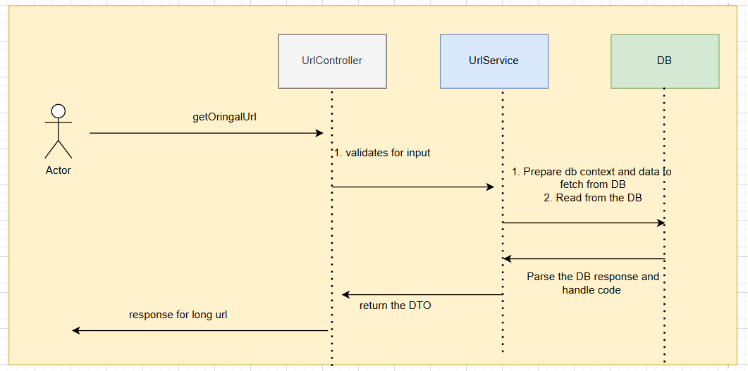

1. Example

Request :

Post host/Api/getOrignalUrl

{

shortUrl : “newgen.lyshorturlexample”

}

Response :

Body

{

longUrl :” https://www.google.com/search?q=somelongUrl”,

shortUrl :” newgen.lyshorturlexample”

}

1. Other